## ****AGV Protocol – Tokenomics Document****

**Version 2.0 – Binance / VC Ready**  
**Date:** August 2025

### ****1. Overview****

**AGV Protocol** is a Real-World Asset (RWA) + DePIN tokenization framework that maps orchard yield, solar power, and compute nodes into verifiable on-chain assets.  
The Tokenomics is designed for **capital efficiency, market stability, and long-term yield alignment**, ensuring balanced interests between asset providers, DAO governance, investors, and ecosystem growth.

### ****2. Token Model****

#### ****Core Tokens****

**GVT (Green Value Token)**

Deterministic supply: **1,000,000,000 GVT**

Minted via Power-to-Mint after IoT/oracle-confirmed productivity (kWh, kg harvest, compute cycles).

Utility: DAO governance, staking, asset adoption, DeFi integration, yield redemption.

**rGGP (Rewarded Green Garden Points)**

Variable supply (DAO budgeted annual emissions).

Earned via NFT adoption, staking, participation in DAO missions.

Convertible into GVT or used for ecosystem benefits (discounts, early access).

### ****3. Supply & Allocation (GVT)****

| **Category** | **Allocation** | **Vesting / Lock-up** |
| --- | --- | --- |
| Public Sale (NFT & Builder LP) | 20% | Unlock upon listing, subject to DEX/CEX liquidity schedule |
| DAO Treasury | 25% | Locked, DAO-governed disbursement |
| Asset Provider Rewards | 20% | Vested over verified yield period |
| Team & Advisors | 15% | 4-year vesting, 1-year cliff |
| Strategic Partnerships | 10% | 6–18 month vesting |
| Liquidity Provision & Market Making | 10% | Locked until MM contracts executed |

### ****4. Supply & Emission (rGGP)****

**Soft Annual Cap:** Determined by DAO budget vote

**Emission Curve:** Decreases over 5 years to control inflation

**Distribution Pathways:** Airdrops, staking rewards, ecosystem bounties

**Source Pool:** DAO Treasury (media/marketing allocations come from here)

### ****5. Utility & Value Accrual****

**Stake GVT → Earn verified rewards**

**Adopt NFTs → Unlock yield rights**

**DeFi Integration:** LP farming, lending collateral, cross-chain swaps

**Governance:** DAO voting, proposal rights, treasury control

**Revenue-Backed Buybacks:** Treasury uses yield revenue to buy GVT in open market

### ****6. Liquidity & Stability Strategy****

**Initial Liquidity:** Allocated from Liquidity Provision & MM pool

**Market Maker Agreements:** 12–24 month contracts with Tier-1 MM firms

**Price Stability Mechanisms:** DAO-controlled buyback & burn, liquidity wall maintenance, emission throttling

### ****7. Governance & Safeguards****

**Multi-sig Treasury:** DAO Elected signers (min. 3 of 5)

**Smart Contract Audit:** Pre-listing audits by Tier-1 firm (CertiK, PeckShield)

**Anti-Rug Protocol:** All GVT allocations subject to DAO release approvals

**Transparent On-chain Reporting:** Real-time yield, token flows, DAO spending

### ****8. Market Benchmarking****

| **Project** | **Market Cap** | **FDV** | **Utility** | **Similarity** |
| --- | --- | --- | --- | --- |
| **Ondo Finance** | $1.2B | $1.6B | RWA fixed income | Partial |
| **Power Ledger** | $350M | $500M | Renewable energy tokenization | High |
| **AGV Protocol** | TBD | Target $80–150M FDV | Multi-asset RWA + DePIN | Unique |

### ****9. Investment Highlights****

**Real-Asset Backing:** Every GVT minted corresponds to verified physical output.

**Balanced Tokenomics:** Fixed allocations for core stakeholders (Asset Provider 20%, Team 15%).

**DAO Governance:** Ensures transparency and community oversight of treasury.

**Price Stability Strategy:** Dedicated liquidity & MM pool with buyback mechanisms.

**Multi-Asset Yield:** Exposure to agriculture, renewable energy, and compute sectors in one token.

### ****10. Token Allocation Diagram****

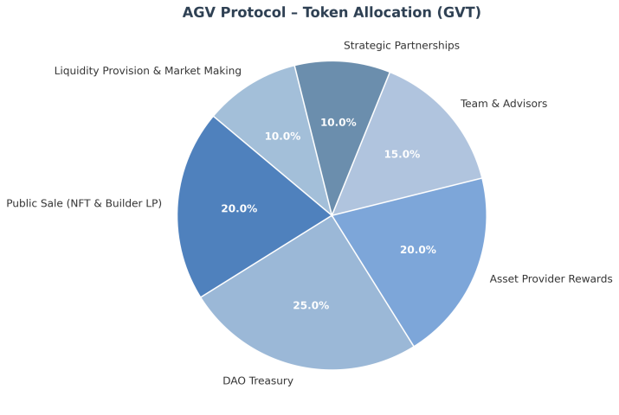

### ****11. Vesting Schedule Chart****

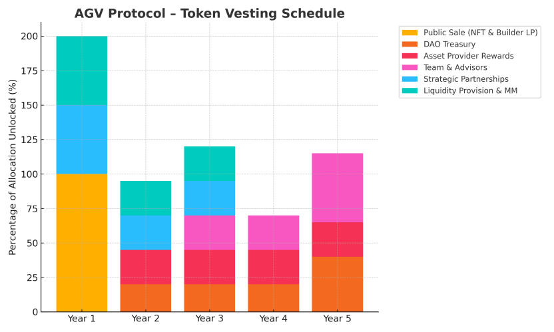

### ****12. Legal & Compliance****

**Jurisdictions:** Compliant with key markets (SG, JP, EU, NZ, HK)

**SAFT Agreement:** For pre-listing investors

**KYC/AML:** Mandatory for public sale participants

**Regulatory Filings:** Asset mapping contracts notarized and filed with relevant jurisdictions

### ****Tokenomics Philosophy****

"AGV Protocol’s token design is built to balance long-term asset yield with immediate investor incentives, ensuring sustainable growth without speculative inflation. Fixed core allocations protect asset providers and execution teams, while DAO-controlled treasury enables adaptive market strategies."

